1). **Single** Inheritance/Simple Inheritance:

**Single inheritance** is damn easy to understand. When a class extends another one class only then we  call it a single inheritance. The below flow diagram shows that class B extends only one class which is A. Here A is a **parent class** of B and B would be  a **child class** of A.

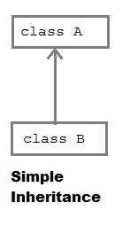**example**

**public** **class** SigleInheritance **extends** Calc {

**public** **static** **void** main(String[] args) {

// **TODO** Auto-generated method stub

SigleInheritance calc=**new** SigleInheritance();

calc.add(20, 30);

calc.sub(20,10);

}

}

**class** Calc {

**int** ans;

**public** **void** add(**int** x,**int** y)

{

ans=x+y;

System.***out***.println("Addition is "+ans);

}

**public** **void** sub(**int** x,**int** y)

{

ans=x-y;

System.***out***.println("Substraction is "+ans);

}

}

**Output**

Addition is 50

Substraction is 10